LAB EXPERIMENTS

NAME :R.ASIF
REG NO :192411163
COURSE NAME : INTERNET PROGRAMMING
COURSE CODE :CSA4311

1 . LIBRARY MANAGEMENT SYSTEM

<!DOCTYPE html>
<html>
<head>
<title>Library Management System</title>
<style>
body{font-family:Arial;background:#f2f2f2;margin:0}
header{background:#2c3e50;color:white;padding:20px;text-align:center}
nav button{padding:10px;margin:5px;background:#3498db;color:white;border:0}
.container{background:white;margin:30px auto;padding:20px;max-width:800px}
input,select{padding:10px;margin:8px;width:90%}
button{padding:10px;background:#3498db;color:white;border:0}
.book{background:#eee;padding:15px;margin:10px}
</style>
</head>

<body>

<header>
<h1>📚 Library Management System</h1>
<button onclick="home()">Home</button>
<button onclick="books()">Books</button>
<button onclick="login()">Login</button>
<button onclick="admin()">Admin</button>
</header>

<div class="container" id="content">
<h2>Welcome to College Library</h2>
<p>Search, borrow and manage library books easily.</p>
</div>

<script>

function home(){
document.getElementById("content").innerHTML=
"<h2>Library Home</h2><p>Welcome Students and Librarians!</p>";
}

function books(){
document.getElementById("content").innerHTML=`
<h2>Search Books</h2>
<input id="search" placeholder="Search Book">
<div class="book"><h3>Java Programming</h3>
<p>Author: Herbert Schildt</p>
<p>Status: Available</p>
<button onclick="borrow()">Borrow</button></div>
<div class="book"><h3>Database Management</h3>
<p>Author: Silberschatz</p>
<p>Status: Available</p>
<button onclick="borrow()">Borrow</button></div>`;
}

function borrow(){
alert("Book Issued Successfully!");
}

function login(){
document.getElementById("content").innerHTML=`
<h2>User Login</h2>
<input placeholder="Email">
<input type="password" placeholder="Password">
<button onclick="alert('Login Successful')">Login</button>`;
}

function admin(){
document.getElementById("content").innerHTML=`
<h2>Librarian Admin</h2>
<input placeholder="Book Name">
<input placeholder="Author">
<input placeholder="Year">
<button onclick="alert('Book Added')">Add Book</button>
<h3>Manage Books</h3>
<button onclick="alert('Book Updated')">Update Book</button>
<button onclick="alert('Book Deleted')">Delete Book</button>
<h3>Issue / Return</h3>
<button onclick="alert('Book Issued')">Issue Book</button>
<button onclick="alert('Book Returned')">Return Book</button>
<h3>Fine</h3>
<input placeholder="Fine Amount">
<button onclick="alert('Fine Added')">Make Fine</button>`;
}

</script>

</body>
</html><!DOCTYPE html>
<html>
<head>
<title>Library Management System</title>
<style>
body{font-family:Arial;background:#f2f2f2;margin:0}
header{background:#2c3e50;color:white;padding:20px;text-align:center}
nav button{padding:10px;margin:5px;background:#3498db;color:white;border:0}
.container{background:white;margin:30px auto;padding:20px;max-width:800px}
input,select{padding:10px;margin:8px;width:90%}
button{padding:10px;background:#3498db;color:white;border:0}
.book{background:#eee;padding:15px;margin:10px}
</style>
</head>

<body>

<header>
<h1>📚 Library Management System</h1>
<button onclick="home()">Home</button>
<button onclick="books()">Books</button>
<button onclick="login()">Login</button>
<button onclick="admin()">Admin</button>
</header>

<div class="container" id="content">
<h2>Welcome to College Library</h2>
<p>Search, borrow and manage library books easily.</p>
</div>

<script>

function home(){
document.getElementById("content").innerHTML=
"<h2>Library Home</h2><p>Welcome Students and Librarians!</p>";
}

function books(){
document.getElementById("content").innerHTML=`
<h2>Search Books</h2>
<input id="search" placeholder="Search Book">
<div class="book"><h3>Java Programming</h3>
<p>Author: Herbert Schildt</p>
<p>Status: Available</p>
<button onclick="borrow()">Borrow</button></div>
<div class="book"><h3>Database Management</h3>
<p>Author: Silberschatz</p>
<p>Status: Available</p>
<button onclick="borrow()">Borrow</button></div>`;
}

function borrow(){
alert("Book Issued Successfully!");
}

function login(){
document.getElementById("content").innerHTML=`
<h2>User Login</h2>
<input placeholder="Email">
<input type="password" placeholder="Password">
<button onclick="alert('Login Successful')">Login</button>`;
}

function admin(){
document.getElementById("content").innerHTML=`
<h2>Librarian Admin</h2>
<input placeholder="Book Name">
<input placeholder="Author">
<input placeholder="Year">
<button onclick="alert('Book Added')">Add Book</button>
<h3>Manage Books</h3>
<button onclick="alert('Book Updated')">Update Book</button>
<button onclick="alert('Book Deleted')">Delete Book</button>
<h3>Issue / Return</h3>
<button onclick="alert('Book Issued')">Issue Book</button>
<button onclick="alert('Book Returned')">Return Book</button>
<h3>Fine</h3>
<input placeholder="Fine Amount">
<button onclick="alert('Fine Added')">Make Fine</button>`;
}
</script>
</body>
</html>

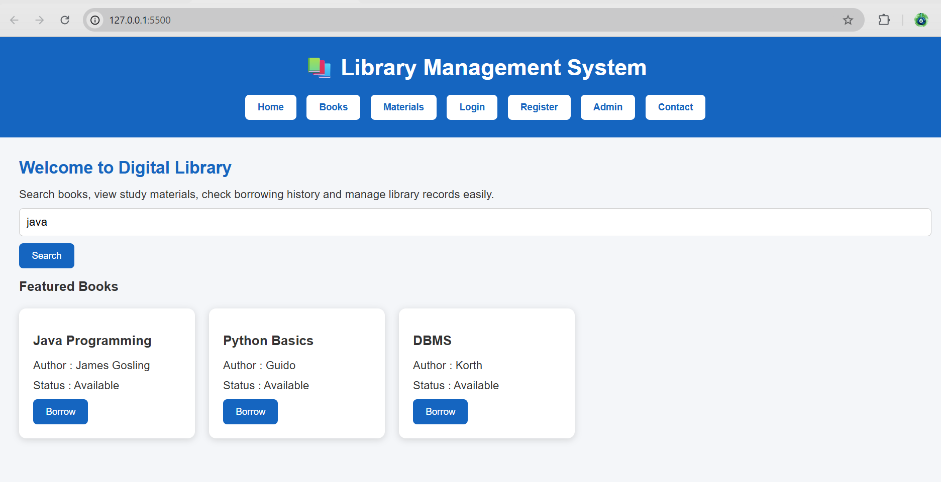
2. Hotel Room Booking

<!DOCTYPE html>
<html>
<head>
<title>Hotel Booking</title>
<style>
body{font-family:Arial;background:#eee;text-align:center}
header{background:#234;color:white;padding:20px}
button,input{padding:10px;margin:5px}
.room{background:white;margin:15px;padding:15px}
</style>
</head>
<body>

<header>
<h1>🏨 Hotel Room Booking</h1>
<button onclick="home()">Home</button>
<button onclick="rooms()">Rooms</button>
<button onclick="login()">Login</button>
<button onclick="booking()">My Bookings</button>
<button onclick="admin()">Admin</button>
</header>

<div id="app">
<h2>Welcome to Our Hotel</h2>
<p>Search and book your room easily.</p>
</div>

<script>
function home(){
app.innerHTML="<h2>Welcome to Our Hotel</h2><p>Comfortable rooms at best prices.</p>";
}

function rooms(){
app.innerHTML=`
<h2>Search Rooms</h2>
<input placeholder="Destination">
<input type="date"><input type="date">
<input placeholder="Guests">
<button onclick="alert('Room Available')">Check Availability</button>
<div class="room"><h3>Single Room</h3><p>$50 | WiFi | AC</p>
<button onclick="book()">Book Now</button></div>
<div class="room"><h3>Double Room</h3><p>$80 | WiFi | AC</p>
<button onclick="book()">Book Now</button></div>`;
}

function book(){
alert("Room booked successfully!");
}

function login(){
app.innerHTML=`
<h2>User Login</h2>
<input placeholder="Email">
<input type="password" placeholder="Password">
<button onclick="alert('Login Successful')">Login</button>
`;
}

function booking(){
app.innerHTML=`
<h2>My Booking</h2>
<p>Room: Double Room</p>
<p>Date: 10-08-2026</p>
<p>Status: Confirmed</p>
<button onclick="alert('Booking Modified')">Modify</button>
<button onclick="alert('Booking Cancelled')">Cancel</button>`;
}

function admin(){
app.innerHTML=`
<h2>Admin Panel</h2>
<input placeholder="Room Type">
<input placeholder="Quantity">
<input placeholder="Price">
<button onclick="alert('Room Updated')">Update Room</button>
<button onclick="alert('Booking Cancelled')">Cancel Booking</button>
<p>Admin can manage rooms, bookings and website pages.</p>`;
}
</script>
</body>
</html>
OUTPUT:
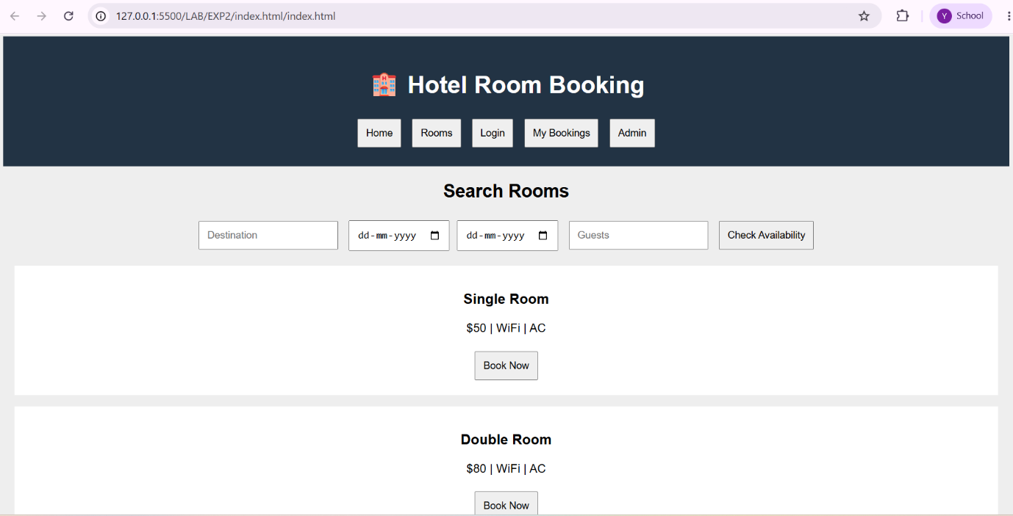

3.ONLINE BUS TICKET BOOKING
<!DOCTYPE html>
<html>
<head>
<title>Bus Ticket Booking</title>
<style>
body{font-family:Arial;background:#eee;text-align:center}
header{background:#234;color:white;padding:20px}
button,input,select{padding:10px;margin:5px}
.bus{background:white;margin:15px;padding:15px}
</style>
</head>
<body>

<header>
<h1>🚌 Bus Ticket Booking System</h1>
<button onclick="home()">Home</button>
<button onclick="search()">Search Bus</button>
<button onclick="login()">Login</button>
<button onclick="register()">Register</button>
<button onclick="booking()">My Booking</button>
<button onclick="admin()">Admin</button>
</header>

<div id="app">
<h2>Welcome to Bus Booking</h2>
<p>Search and book your bus ticket easily.</p>
</div>

<script>
function home(){
app.innerHTML="<h2>Welcome</h2><p>Book your bus tickets online.</p>";
}

function search(){
app.innerHTML=`
<h2>Search Bus</h2>
<input placeholder="From">
<input placeholder="To">
<input type="date">
<input type="time">
<button onclick="alert('Bus Found')">Search</button>
<div class="bus"><h3>Volvo Bus</h3>
<p>Chennai to Bangalore</p><p>Seats Available: 20</p>
<button onclick="book()">Book Ticket</button></div>`;
}

function book(){
alert("Ticket booked successfully!");
}

function login(){
app.innerHTML=`
<h2>Login</h2>
<input placeholder="Username">
<input type="password" placeholder="Password">
<button onclick="alert('Login Successful')">Login</button>
<p>Forgot Password? | Change Password</p>`;
}

function register(){
app.innerHTML=`
<h2>Registration</h2>
<input placeholder="Name"><input placeholder="Email">
<input placeholder="Password">
<button onclick="alert('Registered Successfully')">Register</button>`;
}

function booking(){
app.innerHTML=`
<h2>My Booking</h2><p>Bus: Volvo</p>
<p>Route: Chennai to Bangalore</p>
<button onclick="alert('Booking Cancelled')">Cancel Ticket</button>`;
}

function admin(){
app.innerHTML=`
<h2>Admin Panel</h2>
<input placeholder="Bus Type">
<input placeholder="Route">
<input placeholder="Available Seats">
<button onclick="alert('Bus Updated')">Update Bus</button>
<button onclick="alert('Report Generated')">Generate Report</button>
<p>Admin manages buses, users, comments and reports.</p>`;
}
</script>
</body>
</html>
OUTPUT:
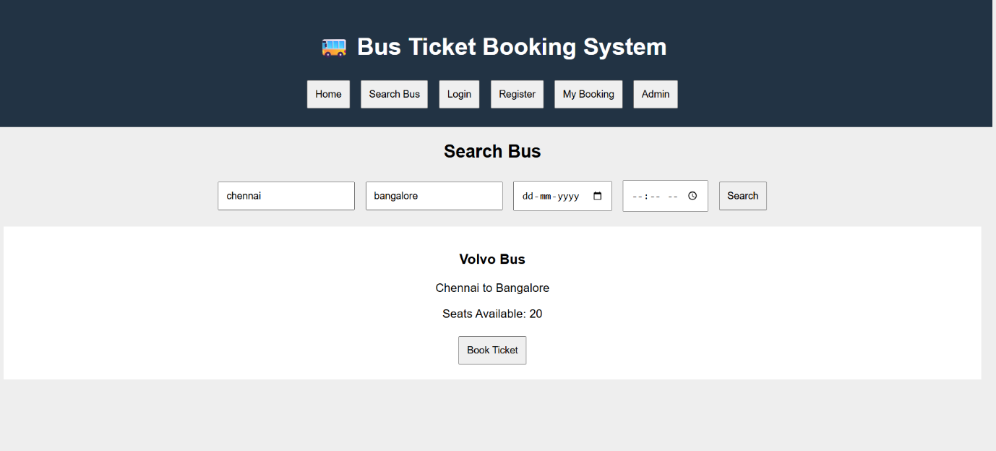

4. TRAIN RESERVATION SYSTEM:
<!DOCTYPE html>
<html>
<head>
<title>Train Reservation System</title>
<style>
body{font-family:Arial;background:#eee;text-align:center}
header{background:#234;color:white;padding:20px}
button,input,select{padding:10px;margin:5px}
.train{background:white;margin:15px;padding:15px}
</style>
</head>
<body>

<header>
<h1>🚆 Train Reservation System</h1>
<button onclick="home()">Home</button>
<button onclick="search()">Search Train</button>
<button onclick="login()">Login</button>
<button onclick="register()">Register</button>
<button onclick="pnr()">Check PNR</button>
<button onclick="admin()">Admin</button>
</header>

<div id="app">
<h2>Welcome to Railway Reservation</h2>
<p>Search trains and reserve your tickets online.</p>
</div>

<script>
function home(){
app.innerHTML="<h2>Welcome</h2><p>Book your train tickets easily.</p>";
}

function search(){
app.innerHTML=`
<h2>Search Train</h2>
<input placeholder="Origin Station">
<input placeholder="Destination Station">
<input type="date">
<select><option>AC</option><option>Sleeper</option><option>General</option></select>
<button onclick="alert('Train Found')">Search</button>
<div class="train"><h3>Express Train</h3>
<p>Available Seats: 25</p><p>Fare: $50</p>
<button onclick="book()">Book Ticket</button></div>`;
}

function book(){
alert("Ticket Booked! PNR: TR123456");
}

function login(){
app.innerHTML=`
<h2>Passenger Login</h2>
<input placeholder="Username">
<input type="password" placeholder="Password">
<button onclick="alert('Login Successful')">Login</button>`;
}

function register(){
app.innerHTML=`
<h2>Passenger Registration</h2>
<input placeholder="Name"><input placeholder="Email">
<input placeholder="Password">
<button onclick="alert('Registration Successful')">Register</button>`;
}

function pnr(){
app.innerHTML=`
<h2>Check PNR Status</h2>
<input placeholder="Enter PNR Number">
<button onclick="alert('Status: Confirmed')">Check Status</button>
<p>PNR Status: Confirmed / RAC / Waiting List</p>`;
}

function admin(){
app.innerHTML=`
<h2>Admin Panel</h2>
<input placeholder="Train Name">
<input placeholder="Train Number">
<input placeholder="Available Seats">
<button onclick="alert('Train Details Updated')">Update Train</button>
<button onclick="alert('Refund Processed')">Process Refund</button>
<p>Admin manages trains, fares, users, PNR and payments.</p>`;
}
</script>
</body>
</html>
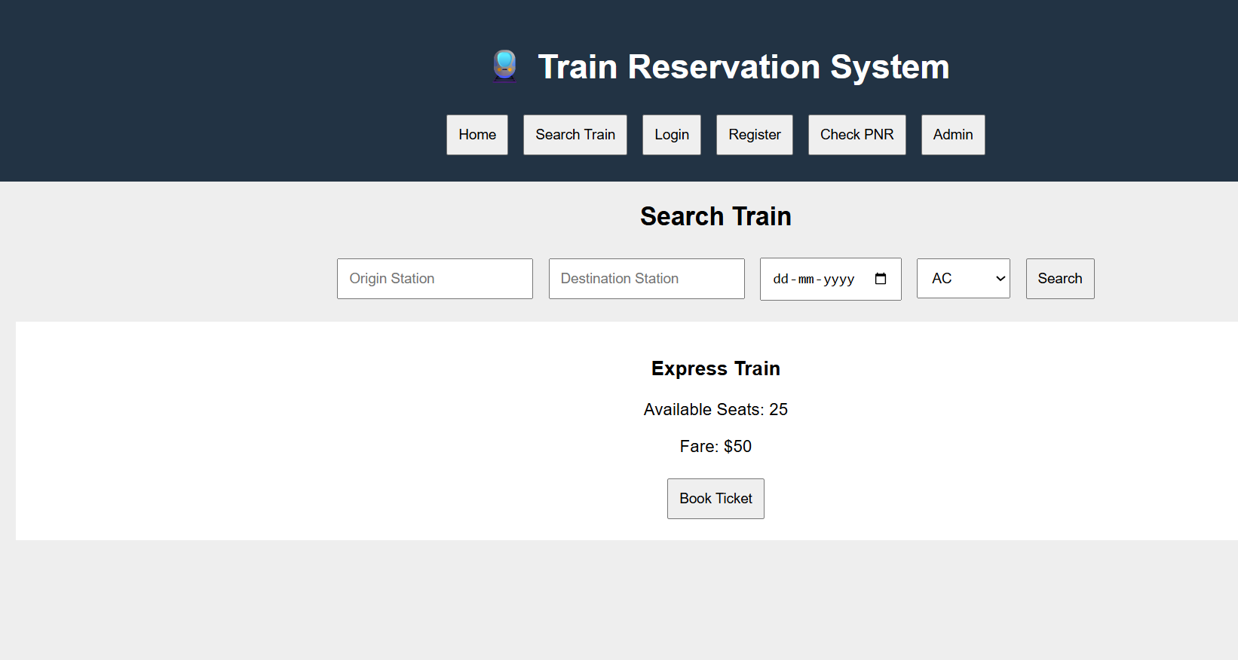

5. FLIGHT RESERVATION SYSTEM
<!DOCTYPE html>
<html>
<head>
<title>Flight Reservation System</title>
<style>
body{font-family:Arial;background:#eee;text-align:center}
header{background:#234;color:white;padding:20px}
button,input,select{padding:10px;margin:5px}
.flight{background:white;margin:15px;padding:15px}
</style>
</head>
<body>

<header>
<h1>✈️ Flight Reservation System</h1>
<button onclick="home()">Home</button>
<button onclick="search()">Search Flight</button>
<button onclick="login()">Login</button>
<button onclick="bookings()">My Ticket</button>
<button onclick="status()">Booking Status</button>
<button onclick="admin()">Admin</button>
</header>

<div id="app">
<h2>Welcome to Flight Reservation</h2>
<p>Search and book your flight tickets online.</p>
</div>

<script>
function home(){
app.innerHTML="<h2>Welcome</h2><p>Book your flight easily and securely.</p>";
}

function search(){
app.innerHTML=`
<h2>Search Flight</h2>
<input placeholder="Destination">
<input type="date">
<select><option>Economy</option><option>Business</option></select>
<button onclick="alert('Flight Found')">Search</button>
<div class="flight"><h3>Air India</h3>
<p>Chennai to Delhi</p><p>Seats Available: 20</p>
<p>Fare: $150</p>
<button onclick="book()">Book Ticket</button></div>`;
}

function book(){
alert("Ticket Booked Successfully!");
}

function login(){
app.innerHTML=`
<h2>Customer Login</h2>
<input placeholder="Email">
<input type="password" placeholder="Password">
<button onclick="alert('Login Successful')">Login</button>
<p>Forgot Password?</p>`;
}

function bookings(){
app.innerHTML=`
<h2>My Ticket</h2>
<p>Flight: Air India</p><p>Status: Confirmed</p>
<button onclick="alert('Ticket Printed')">Print Ticket</button>
<button onclick="alert('Ticket Cancelled')">Cancel Ticket</button>`;
}

function status(){
app.innerHTML=`
<h2>Booking Status</h2>
<input placeholder="Booking ID">
<button onclick="alert('Status: Confirmed')">Check Status</button>`;
}

function admin(){
app.innerHTML=`
<h2>Admin Panel</h2>
<input placeholder="Flight Name">
<input placeholder="Available Seats">
<input placeholder="Flight Fare">
<button onclick="alert('Flight Updated')">Update Flight</button>
<button onclick="alert('Report Generated')">Admin Report</button>
<p>Admin manages flights, seats, users and bookings.</p>`;
}
</script>
</body>
</html>
OUTPUT:

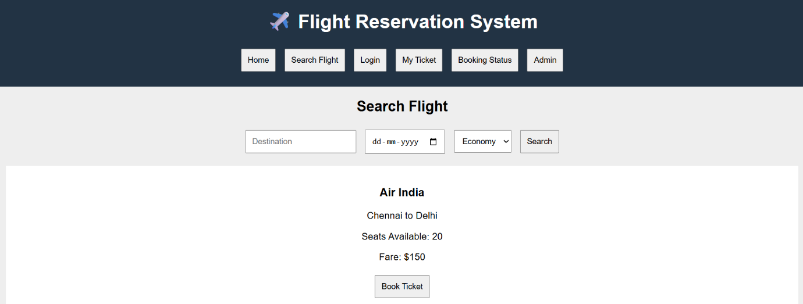

EXPERIMENT-6:
Aim: To develop a responsive Online Cake Ordering System that enables users to browse, customize, and order cakes online, while allowing administrators to manage products, orders, and deliveries efficiently through a web-based platform.

Code:
<!DOCTYPE html>
<html lang="en">
<head>
<meta charset="UTF-8">
<meta name="viewport" content="width=device-width, initial-scale=1.0">
<title>Online Cake Ordering System</title>
<link href="https://cdn.jsdelivr.net/npm/bootstrap@5.3.3/dist/css/bootstrap.min.css" rel="stylesheet">
<style>
body{background:#f8f9fa}
.hero{padding:60px 20px;text-align:center;background:#fff0f5}
.section{display:none;padding:20px}
.active-section{display:block}
.card img{height:200px;object-fit:cover}
.navbar-brand{font-weight:bold}
</style>
</head>
<body>
<nav class="navbar navbar-expand-lg navbar-dark bg-dark">
<div class="container">
<a class="navbar-brand" href="#">Cake Store</a>
<div>
<button class="btn btn-outline-light btn-sm m-1" onclick="showSection('home')">Home</button>
<button class="btn btn-outline-light btn-sm m-1" onclick="showSection('cakes')">Cakes</button>
<button class="btn btn-outline-light btn-sm m-1" onclick="showSection('cart')">Cart</button>
<button class="btn btn-outline-light btn-sm m-1" onclick="showSection('orders')">Orders</button>
<button class="btn btn-outline-light btn-sm m-1" onclick="showSection('login')">Login</button>
<button class="btn btn-outline-light btn-sm m-1" onclick="showSection('register')">Register</button>
<button class="btn btn-warning btn-sm m-1" onclick="showSection('admin')">Admin</button>
</div>
</div>
</nav>

<div id="home" class="section active-section">
<div class="hero">
<h1>Online Cake Ordering System</h1>
<p>Order delicious cakes for every occasion.</p>
</div>
</div>

<div id="cakes" class="section container">
<h2>Cakes</h2>
<div class="row">
<div class="col-md-4"><div class="card"><img src="https://images.unsplash.com/photo-1578985545062-69928b1d9587"><div class="card-body"><h5>Chocolate Cake</h5><p>₹500</p><button class="btn btn-primary" onclick="addCart('Chocolate Cake')">Add to Cart</button></div></div></div>
<div class="col-md-4"><div class="card"><img src="https://images.unsplash.com/photo-1464349095431-e9a21285b5f3"><div class="card-body"><h5>Vanilla Cake</h5><p>₹450</p><button class="btn btn-primary" onclick="addCart('Vanilla Cake')">Add to Cart</button></div></div></div>
<div class="col-md-4"><div class="card"><img src="https://images.unsplash.com/photo-1486427944299-d1955d23e34d"><div class="card-body"><h5>Red Velvet</h5><p>₹650</p><button class="btn btn-primary" onclick="addCart('Red Velvet')">Add to Cart</button></div></div></div>
</div>
</div>

<div id="cart" class="section container">
<h2>Cart</h2>
<ul id="cartList"></ul>
</div>

<div id="orders" class="section container">
<h2>My Orders</h2>
<table class="table">
<tr><th>Order ID</th><th>Cake</th><th>Status</th></tr>
<tr><td>101</td><td>Chocolate Cake</td><td>Shipped</td></tr>
</table>
</div>

<div id="login" class="section container">
<h2>Login</h2>
<input class="form-control mb-2" placeholder="Email">
<input class="form-control mb-2" type="password" placeholder="Password">
<button class="btn btn-success">Login</button>
</div>

<div id="register" class="section container">
<h2>Register</h2>
<input class="form-control mb-2" placeholder="Name">
<input class="form-control mb-2" placeholder="Email">
<input class="form-control mb-2" type="password" placeholder="Password">
<button class="btn btn-primary">Register</button>
</div>

<div id="admin" class="section container">
<h2>Admin Dashboard</h2>
<ul>
<li>Manage Products</li>
<li>Upload Images</li>
<li>Manage Orders</li>
<li>Update Shipping Status</li>
<li>Manage Users</li>
</ul>
</div>

<script>
function showSection(id){
document.querySelectorAll('.section').forEach(s=>s.classList.remove('active-section'));
document.getElementById(id).classList.add('active-section');
}
function addCart(item){
let li=document.createElement('li');
li.innerText=item;
document.getElementById('cartList').appendChild(li);
alert(item+" added to cart");
}
</script>
</body>
</html>

Output:
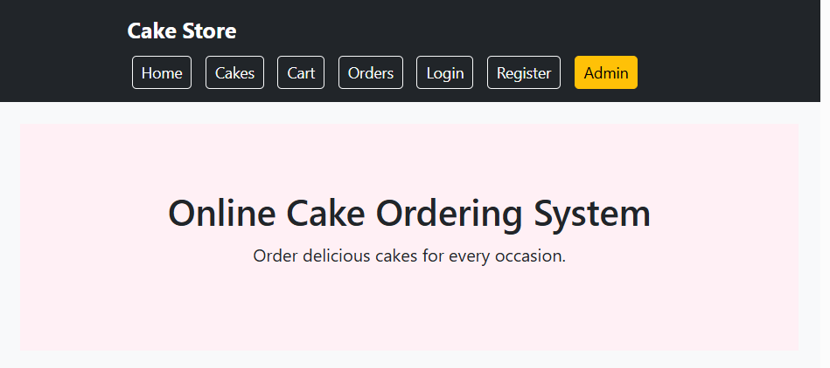
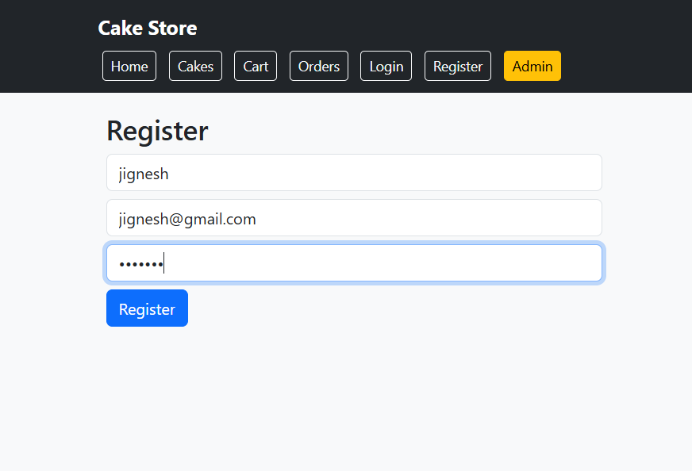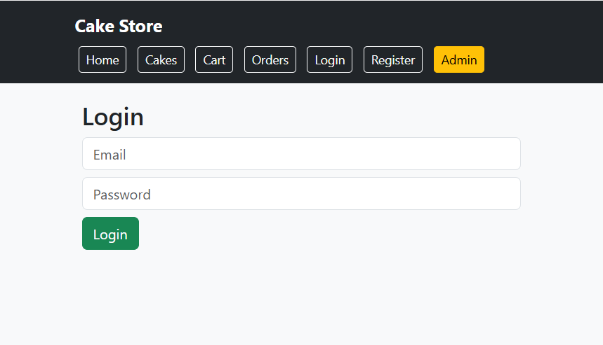

EXPERIMENT-7:
Aim: To develop an online Beauty Parlour Appointment Booking System that enables customers to book salon services, select stylists, schedule appointments, make online payments, and manage reservations efficiently through a responsive web application.
Code:
<!DOCTYPE html>
<html lang="en">
<head>
<meta charset="UTF-8">
<meta name="viewport" content="width=device-width, initial-scale=1.0">
<title>Beauty Parlour Appointment Booking System</title>

<link href="https://cdn.jsdelivr.net/npm/bootstrap@5.3.3/dist/css/bootstrap.min.css" rel="stylesheet">

<style>
body{
background:#f8f9fa;
font-family:Arial, sans-serif;
}
.hero{
background:linear-gradient(to right,#ff69b4,#ffb6c1);
color:white;
text-align:center;
padding:70px 20px;
}
.section{
display:none;
padding:20px;
}
.active{
display:block;
}
.card img{
height:220px;
object-fit:cover;
}
.footer{
background:#222;
color:white;
text-align:center;
padding:15px;
margin-top:20px;
}
</style>
</head>
<body>

<!-- Navigation -->
<nav class="navbar navbar-expand-lg navbar-dark bg-dark">
<div class="container">
<a class="navbar-brand" href="#">Beauty Parlour</a>

<div>
<button class="btn btn-outline-light btn-sm m-1" onclick="showSection('home')">Home</button>
<button class="btn btn-outline-light btn-sm m-1" onclick="showSection('services')">Services</button>
<button class="btn btn-outline-light btn-sm m-1" onclick="showSection('booking')">Book</button>
<button class="btn btn-outline-light btn-sm m-1" onclick="showSection('appointments')">My Appointments</button>
<button class="btn btn-outline-light btn-sm m-1" onclick="showSection('login')">Login</button>
<button class="btn btn-warning btn-sm m-1" onclick="showSection('admin')">Admin</button>
</div>

</div>
</nav>

<!-- Home -->
<div id="home" class="section active">
<div class="hero">
<h1>Beauty Parlour Appointment Booking</h1>
<p>Book Your Favourite Beauty Services Online</p>
<button class="btn btn-light" onclick="showSection('booking')">
Book Appointment
</button>
</div>
</div>

<!-- Services -->
<div id="services" class="section container">
<h2 class="mb-4">Our Services</h2>

<div class="row">

<div class="col-md-4">
<div class="card">
<img src="https://images.unsplash.com/photo-1522337360788-8b13dee7a37e">
<div class="card-body">
<h5>Hair Styling</h5>
<p>Professional hair styling services.</p>
</div>
</div>
</div>

<div class="col-md-4">
<div class="card">
<img src="https://images.unsplash.com/photo-1487412720507-e7ab37603c6f">
<div class="card-body">
<h5>Facial Treatment</h5>
<p>Skin care and facial treatments.</p>
</div>
</div>
</div>

<div class="col-md-4">
<div class="card">
<img src="https://images.unsplash.com/photo-1515377905703-c4788e51af15">
<div class="card-body">
<h5>Bridal Makeup</h5>
<p>Special makeup packages.</p>
</div>
</div>
</div>

</div>
</div>

<!-- Booking -->
<div id="booking" class="section container">
<h2>Book Appointment</h2>

<form>
<input type="text" class="form-control mb-3" placeholder="Customer Name">

<select class="form-control mb-3">
<option>Select Service</option>
<option>Hair Styling</option>
<option>Facial Treatment</option>
<option>Bridal Makeup</option>
<option>Manicure</option>
</select>

<select class="form-control mb-3">
<option>Select Stylist</option>
<option>Priya</option>
<option>Divya</option>
<option>Anjali</option>
</select>

<input type="date" class="form-control mb-3">

<input type="time" class="form-control mb-3">

<button type="button" class="btn btn-success"
onclick="alert('Appointment Booked Successfully!')">
Book Appointment
</button>
</form>

</div>

<!-- My Appointments -->
<div id="appointments" class="section container">

<h2>My Appointments</h2>

<table class="table table-bordered">
<tr>
<th>ID</th>
<th>Service</th>
<th>Date</th>
<th>Status</th>
</tr>

<tr>
<td>101</td>
<td>Hair Styling</td>
<td>10-08-2026</td>
<td>Confirmed</td>
</tr>

<tr>
<td>102</td>
<td>Facial</td>
<td>15-08-2026</td>
<td>Pending</td>
</tr>

</table>

</div>

<!-- Login -->
<div id="login" class="section container">

<h2>Login</h2>

<input type="email"
class="form-control mb-3"
placeholder="Email">

<input type="password"
class="form-control mb-3"
placeholder="Password">

<button class="btn btn-primary">
Login
</button>

</div>

<!-- Admin -->
<div id="admin" class="section container">

<h2>Admin Dashboard</h2>

<div class="card p-3">
<ul>
<li>Manage Services</li>
<li>Manage Stylists</li>
<li>View Appointments</li>
<li>Update Reservation Status</li>
<li>Manage Customers</li>
<li>Send SMS/Notifications</li>
<li>Manage Payments</li>
<li>View Feedback</li>
</ul>
</div>

</div>

<div class="footer">
© 2026 Beauty Parlour Appointment Booking System
</div>

<script>
function showSection(id)
{
document.querySelectorAll('.section')
.forEach(section =>
section.classList.remove('active'));

document.getElementById(id)
.classList.add('active');
}
</script>

</body>
</html>

Output:
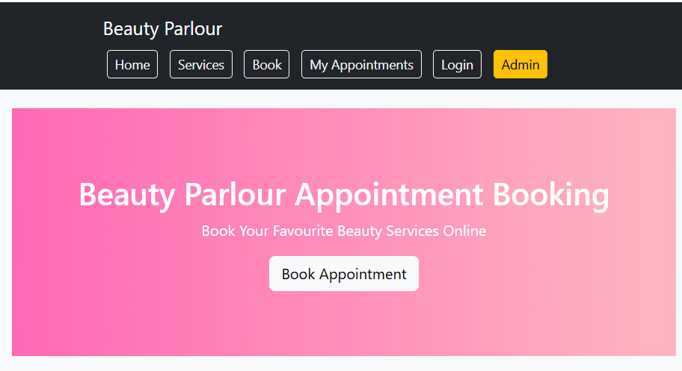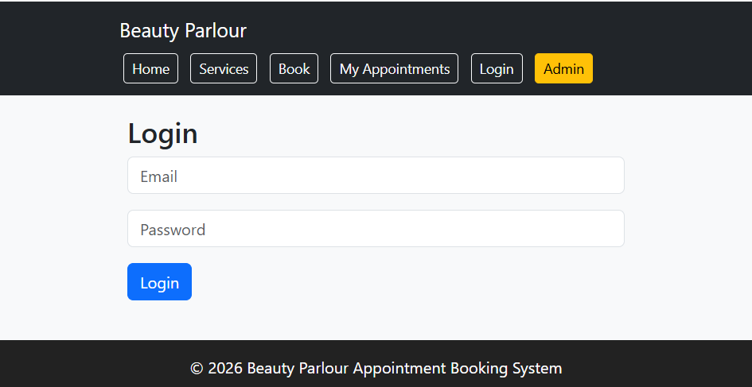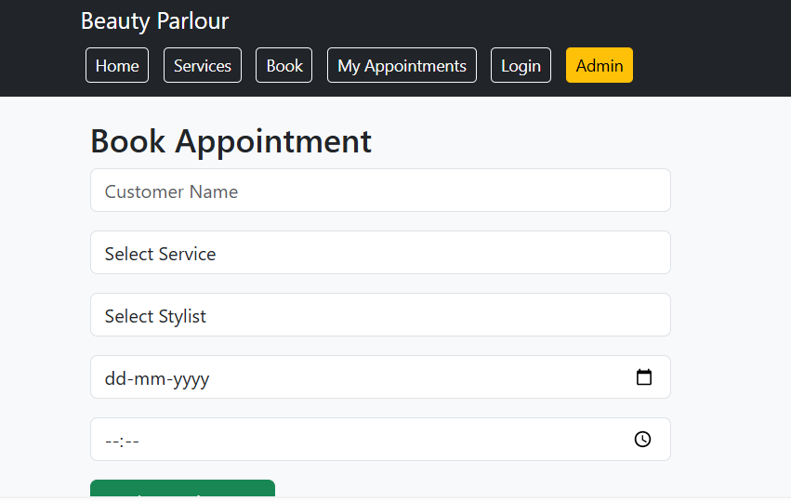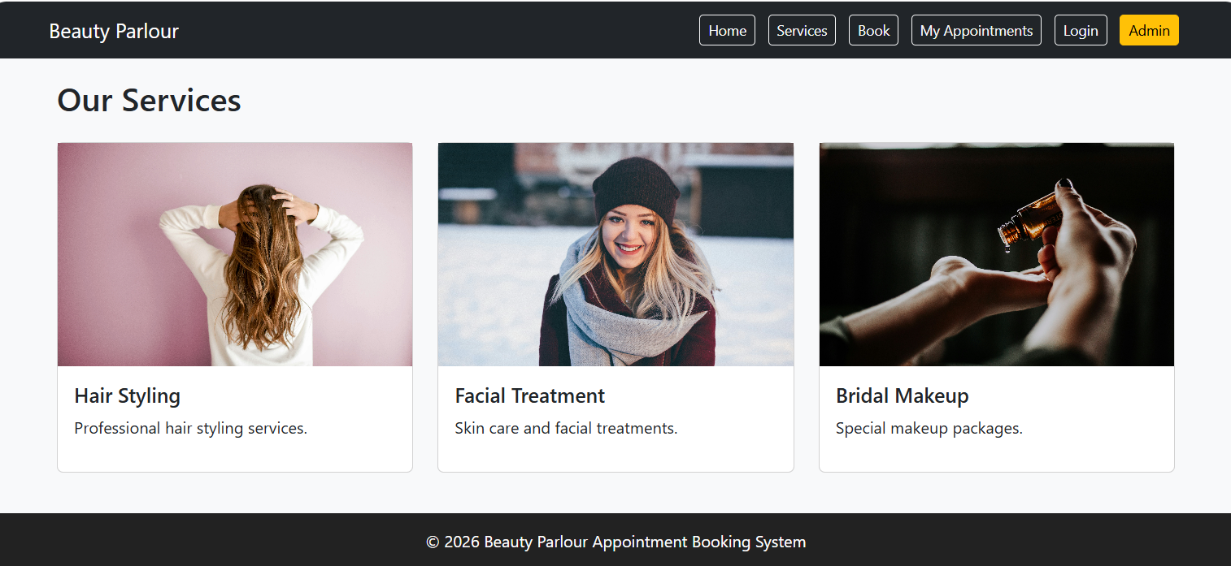

EXPERIMENT-8:
Aim: To develop an online Hospital Appointment Booking System that enables patients to search hospitals and doctors, book appointments, manage schedules, and receive appointment updates through a secure and user-friendly web application.

Code:
<!DOCTYPE html>
<html lang="en">
<head>
<meta charset="UTF-8">
<meta name="viewport" content="width=device-width, initial-scale=1.0">
<title>MedCare Hospital Appointment System</title>

<link href="https://cdn.jsdelivr.net/npm/bootstrap@5.3.3/dist/css/bootstrap.min.css" rel="stylesheet">

<style>
body{
background:#f4f6f9;
font-family:Arial,sans-serif;
}
.hero{
background:linear-gradient(to right,#007bff,#00c6ff);
color:white;
text-align:center;
padding:80px 20px;
}
.section{
display:none;
padding:20px;
}
.active{
display:block;
}
.card{
box-shadow:0 2px 10px rgba(0,0,0,0.1);
}
.footer{
background:#212529;
color:white;
text-align:center;
padding:15px;
margin-top:20px;
}
</style>
</head>
<body>

<!-- Navbar -->
<nav class="navbar navbar-expand-lg navbar-dark bg-dark">
<div class="container">
<a class="navbar-brand" href="#">MedCare Hospital</a>

<div>
<button class="btn btn-outline-light btn-sm m-1" onclick="showSection('home')">Home</button>
<button class="btn btn-outline-light btn-sm m-1" onclick="showSection('doctors')">Doctors</button>
<button class="btn btn-outline-light btn-sm m-1" onclick="showSection('booking')">Book Appointment</button>
<button class="btn btn-outline-light btn-sm m-1" onclick="showSection('history')">History</button>
<button class="btn btn-outline-light btn-sm m-1" onclick="showSection('login')">Login</button>
<button class="btn btn-warning btn-sm m-1" onclick="showSection('admin')">Admin</button>
</div>
</div>
</nav>

<!-- Home -->
<div id="home" class="section active">
<div class="hero">
<h1>Hospital Appointment Booking System</h1>
<p>Book Appointments with Doctors Anytime, Anywhere</p>
<button class="btn btn-light" onclick="showSection('booking')">
Book Now
</button>
</div>
</div>

<!-- Doctors -->
<div id="doctors" class="section container">
<h2 class="mb-4">Available Doctors</h2>

<div class="row">

<div class="col-md-4">
<div class="card">
<div class="card-body">
<h4>Dr. Rajesh</h4>
<p>Cardiologist</p>
<p>Experience: 10 Years</p>
</div>
</div>
</div>

<div class="col-md-4">
<div class="card">
<div class="card-body">
<h4>Dr. Priya</h4>
<p>Dermatologist</p>
<p>Experience: 8 Years</p>
</div>
</div>
</div>

<div class="col-md-4">
<div class="card">
<div class="card-body">
<h4>Dr. Kumar</h4>
<p>Orthopedic</p>
<p>Experience: 12 Years</p>
</div>
</div>
</div>

</div>
</div>

<!-- Booking -->
<div id="booking" class="section container">
<h2>Book Appointment</h2>

<form>

<input type="text"
class="form-control mb-3"
placeholder="Patient Name">

<input type="email"
class="form-control mb-3"
placeholder="Email">

<select class="form-control mb-3">
<option>Select Doctor</option>
<option>Dr. Rajesh</option>
<option>Dr. Priya</option>
<option>Dr. Kumar</option>
</select>

<input type="date" class="form-control mb-3">

<input type="time" class="form-control mb-3">

<button type="button"
class="btn btn-success"
onclick="alert('Appointment Booked Successfully!')">
Book Appointment
</button>

</form>
</div>

<!-- History -->
<div id="history" class="section container">

<h2>Appointment History</h2>

<table class="table table-bordered">
<tr>
<th>ID</th>
<th>Doctor</th>
<th>Date</th>
<th>Status</th>
</tr>

<tr>
<td>201</td>
<td>Dr. Rajesh</td>
<td>12-08-2026</td>
<td>Confirmed</td>
</tr>

<tr>
<td>202</td>
<td>Dr. Priya</td>
<td>18-08-2026</td>
<td>Pending</td>
</tr>

</table>

</div>

<!-- Login -->
<div id="login" class="section container">

<h2>Patient Login</h2>

<input type="email"
class="form-control mb-3"
placeholder="Email">

<input type="password"
class="form-control mb-3"
placeholder="Password">

<button class="btn btn-primary">
Login
</button>

</div>

<!-- Admin -->
<div id="admin" class="section container">

<h2>Admin Dashboard</h2>

<div class="card p-3">
<ul>
<li>Manage Doctors</li>
<li>Manage Hospitals</li>
<li>Manage Appointments</li>
<li>View Appointment Statistics</li>
<li>Manage Reviews & Ratings</li>
<li>Update Doctor Schedules</li>
<li>Manage Patients</li>
<li>Generate Reports</li>
</ul>
</div>

</div>

<div class="footer">
© 2026 MedCare Hospital Appointment Booking System
</div>

<script>
function showSection(id)
{
document.querySelectorAll('.section')
.forEach(section =>
section.classList.remove('active'));

document.getElementById(id)
.classList.add('active');
}
</script>

</body>
</html>
Output:
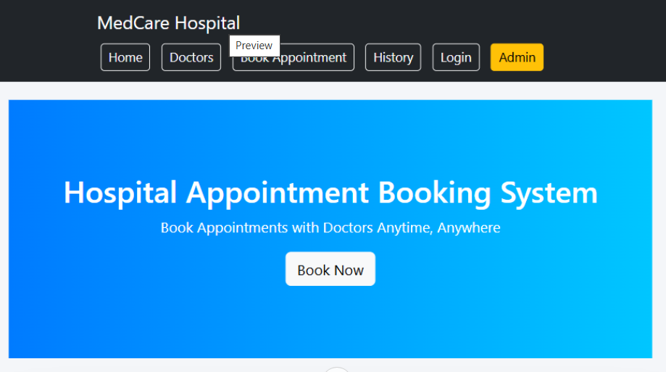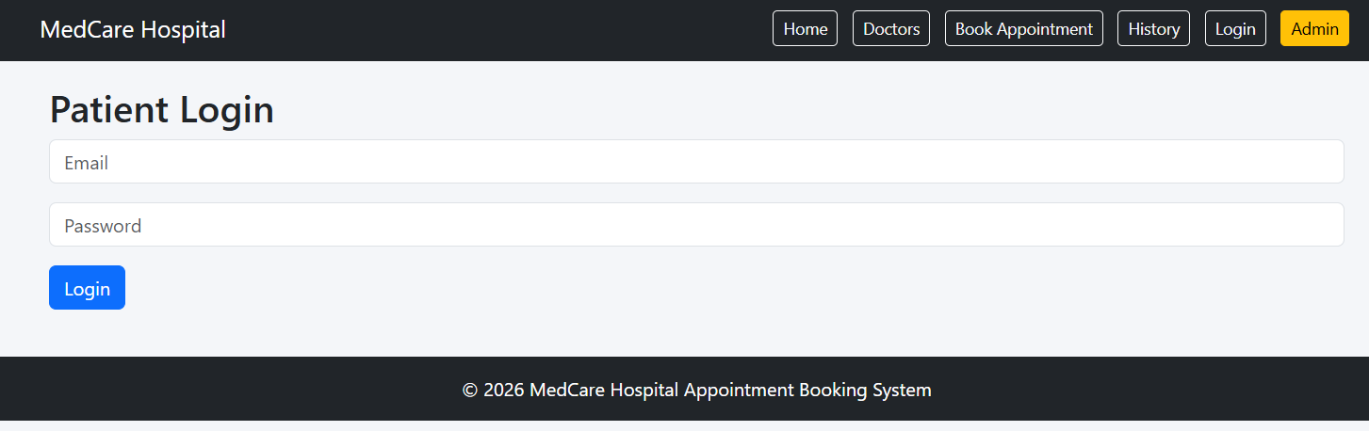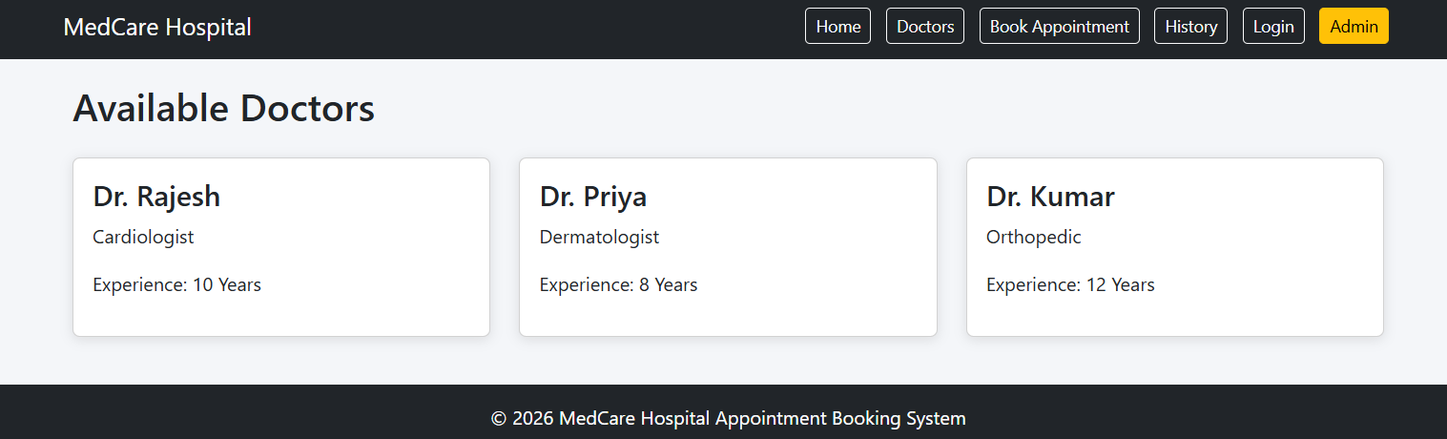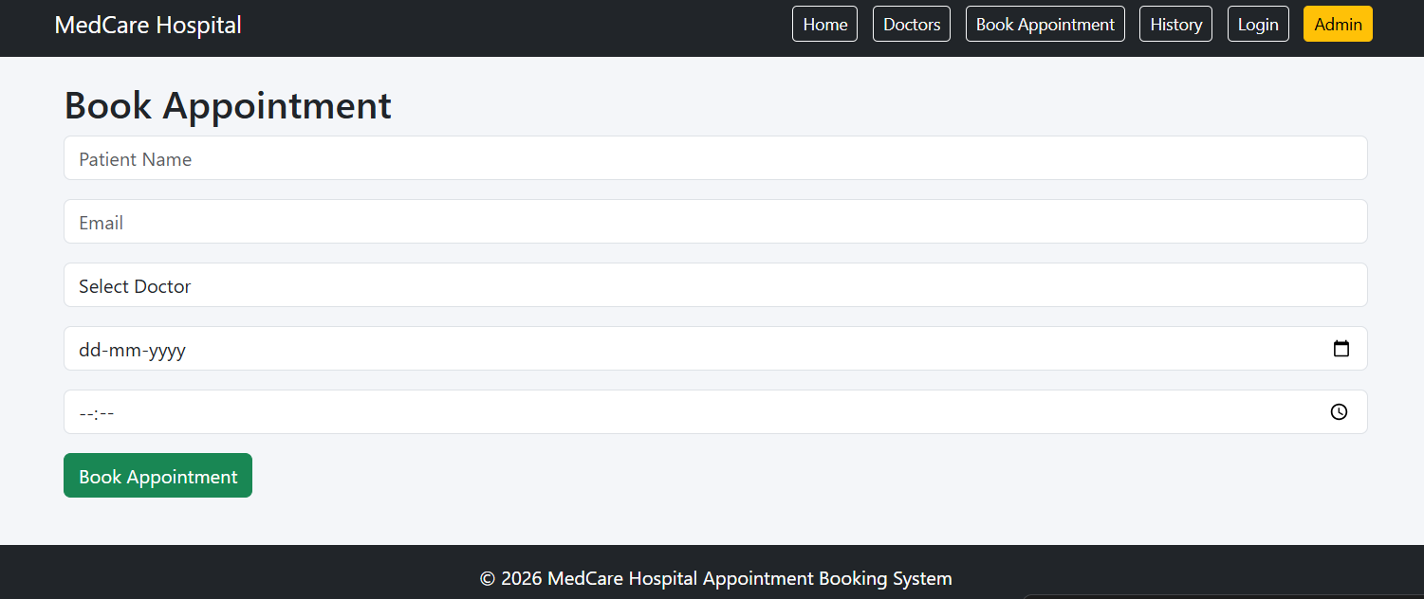

Experiment-9:
Aim: To develop an online Hospital Appointment Booking System that allows patients to search hospitals and doctors, book appointments, manage appointment schedules, and receive notifications through a secure and user-friendly web platform.

Code:
<!DOCTYPE html>
<html>
<head>
<title>Hospital Appointment Booking System</title>
<style>
body{
font-family: Arial, sans-serif;
background:#f4f6f9;
margin:0;
}
header{
background:#007bff;
color:white;
padding:15px;
text-align:center;
}
nav{
background:#333;
padding:10px;
text-align:center;
}
nav a{
color:white;
text-decoration:none;
margin:15px;
}
.container{
padding:20px;
}
.card{
background:white;
padding:15px;
margin:10px 0;
border-radius:5px;
box-shadow:0 0 5px gray;
}
input,select{
width:100%;
padding:10px;
margin:8px 0;
}
button{
background:#28a745;
color:white;
border:none;
padding:10px 20px;
cursor:pointer;
}
footer{
background:#222;
color:white;
text-align:center;
padding:10px;
margin-top:20px;
}
</style>
</head>
<body>

<header>
<h1>MedCare Hospital Appointment Booking System</h1>
</header>

<nav>
<a href="#">Home</a>
<a href="#">Doctors</a>
<a href="#">Appointments</a>
<a href="#">Login</a>
</nav>

<div class="container">

<div class="card">
<h2>Patient Registration</h2>
<input type="text" placeholder="Patient Name">
<input type="email" placeholder="Email">
<input type="password" placeholder="Password">
<button>Register</button>
</div>

<div class="card">
<h2>Book Appointment</h2>

<select>
<option>Select Doctor</option>
<option>Dr. Rajesh - Cardiologist</option>
<option>Dr. Priya - Dermatologist</option>
<option>Dr. Kumar - Orthopedic</option>
</select>

<input type="date">
<input type="time">

<button onclick="bookAppointment()">
Book Appointment
</button>
</div>

<div class="card">
<h2>Appointment Status</h2>

<table border="1" width="100%">
<tr>
<th>Appointment ID</th>
<th>Doctor</th>
<th>Date</th>
<th>Status</th>
</tr>

<tr>
<td>1001</td>
<td>Dr. Rajesh</td>
<td>10-08-2026</td>
<td>Confirmed</td>
</tr>
</table>
</div>

<div class="card">
<h2>Admin Dashboard</h2>
<ul>
<li>Manage Doctors</li>
<li>Manage Hospitals</li>
<li>Manage Appointments</li>
<li>View Statistics</li>
<li>Generate Reports</li>
</ul>
</div>

</div>

<footer>
© 2026 Hospital Appointment Booking System
</footer>

<script>
function bookAppointment()
{
alert("Appointment Booked Successfully!");
}
</script>

</body>
</html>

Output:
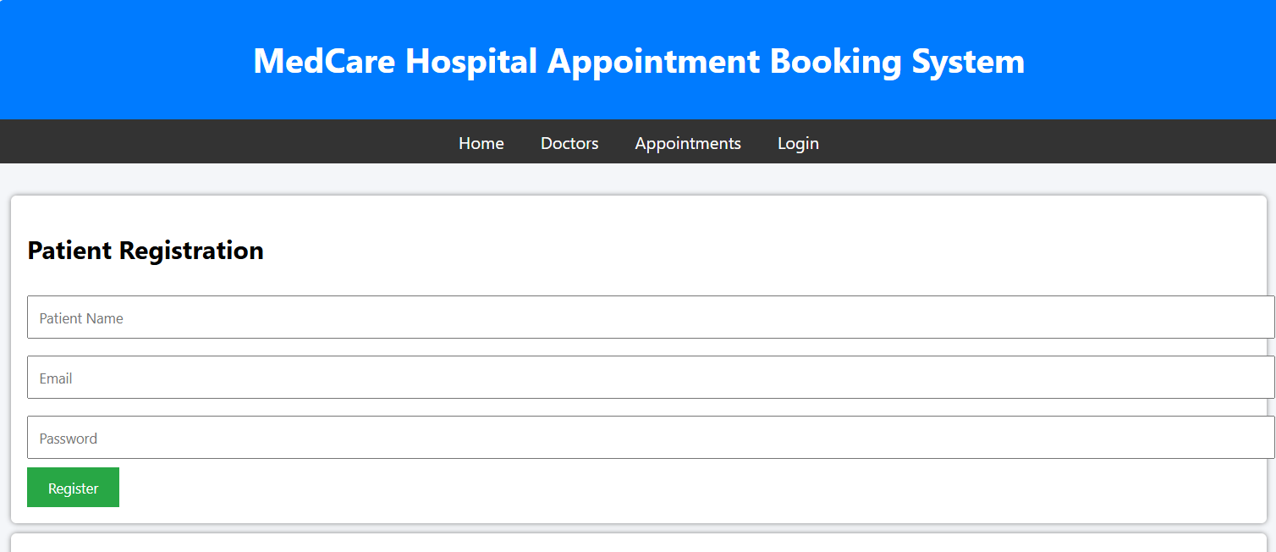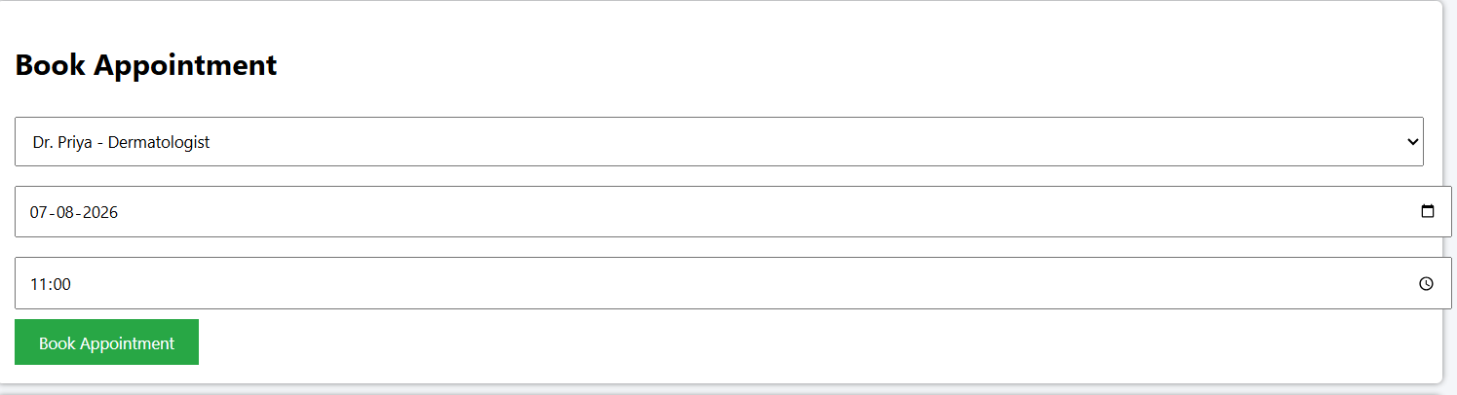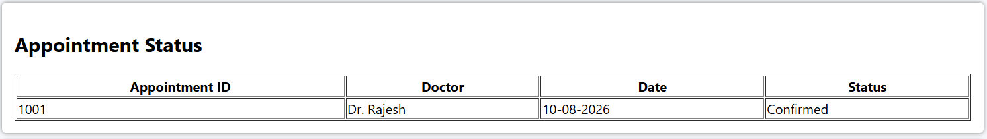

Experiment-10:
Aim: To develop an online fashion e-commerce platform that enables customers to browse, search, and purchase fashion products, manage orders, and make secure online payments through a user-friendly web application.

Code:
<!DOCTYPE html>
<html lang="en">
<head>
<meta charset="UTF-8">
<meta name="viewport" content="width=device-width, initial-scale=1.0">
<title>StyleHub Fashion E-Commerce</title>

<link href="https://cdn.jsdelivr.net/npm/bootstrap@5.3.3/dist/css/bootstrap.min.css" rel="stylesheet">

<style>
body{
font-family: Arial, sans-serif;
background:#f8f9fa;
}

.hero{
background: linear-gradient(135deg,#6f42c1,#e83e8c);
color:white;
text-align:center;
padding:80px 20px;
}

.section{
display:none;
padding:20px;
}

.active{
display:block;
}

.card{
margin-bottom:20px;
}

.card img{
height:250px;
object-fit:cover;
}

.footer{
background:#212529;
color:white;
text-align:center;
padding:15px;
margin-top:20px;
}
</style>
</head>
<body>

<!-- Navbar -->
<nav class="navbar navbar-expand-lg navbar-dark bg-dark">
<div class="container">
<a class="navbar-brand" href="#">StyleHub</a>

<div>
<button class="btn btn-outline-light btn-sm m-1" onclick="showSection('home')">Home</button>
<button class="btn btn-outline-light btn-sm m-1" onclick="showSection('products')">Products</button>
<button class="btn btn-outline-light btn-sm m-1" onclick="showSection('cart')">Cart</button>
<button class="btn btn-outline-light btn-sm m-1" onclick="showSection('orders')">Orders</button>
<button class="btn btn-outline-light btn-sm m-1" onclick="showSection('login')">Login</button>
<button class="btn btn-warning btn-sm m-1" onclick="showSection('admin')">Admin</button>
</div>
</div>
</nav>

<!-- Home -->
<div id="home" class="section active">
<div class="hero">
<h1>StyleHub Fashion Store</h1>
<p>Discover the Latest Fashion Trends</p>
<button class="btn btn-light" onclick="showSection('products')">
Shop Now
</button>
</div>
</div>

<!-- Products -->
<div id="products" class="section container">

<h2 class="mb-4">Fashion Collection</h2>

<div class="row">

<div class="col-md-4">
<div class="card">
<img src="https://images.unsplash.com/photo-1521572163474-6864f9cf17ab" class="card-img-top">
<div class="card-body">
<h5>Men's Casual Shirt</h5>
<p>Price: ₹999</p>
<button class="btn btn-primary" onclick="addToCart('Men Casual Shirt')">
Add to Cart
</button>
</div>
</div>
</div>

<div class="col-md-4">
<div class="card">
<img src="https://images.unsplash.com/photo-1483985988355-763728e1935b" class="card-img-top">
<div class="card-body">
<h5>Women's Dress</h5>
<p>Price: ₹1499</p>
<button class="btn btn-primary" onclick="addToCart('Women Dress')">
Add to Cart
</button>
</div>
</div>
</div>

<div class="col-md-4">
<div class="card">
<img src="https://images.unsplash.com/photo-1542291026-7eec264c27ff" class="card-img-top">
<div class="card-body">
<h5>Fashion Shoes</h5>
<p>Price: ₹1999</p>
<button class="btn btn-primary" onclick="addToCart('Fashion Shoes')">
Add to Cart
</button>
</div>
</div>
</div>

</div>
</div>

<!-- Cart -->
<div id="cart" class="section container">
<h2>Shopping Cart</h2>
<ul id="cartItems" class="list-group"></ul>
</div>

<!-- Orders -->
<div id="orders" class="section container">
<h2>My Orders</h2>

<table class="table table-bordered">
<tr>
<th>Order ID</th>
<th>Product</th>
<th>Status</th>
</tr>

<tr>
<td>5001</td>
<td>Men's Casual Shirt</td>
<td>Delivered</td>
</tr>

<tr>
<td>5002</td>
<td>Fashion Shoes</td>
<td>Shipped</td>
</tr>

</table>
</div>

<!-- Login -->
<div id="login" class="section container">

<h2>User Login</h2>

<input type="email"
class="form-control mb-3"
placeholder="Email">

<input type="password"
class="form-control mb-3"
placeholder="Password">

<button class="btn btn-success">
Login
</button>

</div>

<!-- Admin -->
<div id="admin" class="section container">

<h2>Admin Dashboard</h2>

<div class="card p-3">

<ul>
<li>Manage Products</li>
<li>Add New Products</li>
<li>Update Product Prices</li>
<li>Manage Orders</li>
<li>Manage Customers</li>
<li>Sales Reports</li>
<li>Category Management</li>
<li>Inventory Management</li>
</ul>

</div>

</div>

<div class="footer">
© 2026 StyleHub Fashion E-Commerce Platform
</div>

<script>

function showSection(id)
{
document.querySelectorAll('.section')
.forEach(section =>
section.classList.remove('active'));

document.getElementById(id)
.classList.add('active');
}

function addToCart(product)
{
let item=document.createElement("li");
item.className="list-group-item";
item.innerText=product;

document.getElementById("cartItems")
.appendChild(item);

alert(product + " added to cart!");
}

</script>

</body>
</html>
Output:
